Yarmouk University


Information Technology and Computer Science
Information Systems (IS)

Smart Focus Student Monitoring system

Sarah Fouad Abdel Latif Al-Hawamdeh 2022902058
Hiba Zyad Mohammed Odibat 2021902136

Supervisor
Dr.Abrar

Acknowledgement

Table of content

Table of figures

- Introduction

In modern educational environments, monitoring student attention during lectures is crucial for effective learning. Many students experience boredom or drowsiness inside classrooms, especially with long and consecutive lectures without sufficient breaks, which negatively affects their ability to focus, comprehend, and actively participate. Traditional methods of assessing student attention rely on teachers’ subjective observations, which may not accurately reflect the actual level of students’ concentration or mental fatigue.

With the rapid advancement of Artificial Intelligence (AI) and Computer Vision, it is now possible to develop intelligent systems capable of analyzing students’ attention in real-time and objectively. This project aims to design a smart system for monitoring student focus in the classroom using AI techniques, with the goal of supporting the educational process and enhancing the learning experience from both the students’ and instructors’ perspectives. The system provides teachers with precise and actionable insights into individual and overall class engagement, enabling timely interventions—such as adjusting teaching methods or incorporating short breaks—to reduce boredom and drowsiness and improve learning outcomes..

- Project Overview and Objectives

Project Overview
The proposed system is an intelligent platform designed to monitor student focus during lectures using classroom cameras, which we implement as students using a computer camera. Many students often experience drowsiness or boredom during long or consecutive lectures, negatively affecting their understanding and participation. This system analyzes eye movements and head posture to accurately evaluate attention levels in real-time.

The system features an interactive dashboard that continuously displays individual and class-wide focus metrics. Instructors can start and stop monitoring sessions, receive immediate alerts when overall attention drops below a certain threshold, and access detailed reports for current and past lectures. The system also includes random student selection and short interactive questions to re-engage students and maintain their focus throughout the lecture.

This approach aims to bridge the gap between students and instructors by providing actionable insights, enabling evidence-based teaching decisions, improving classroom engagement, and enhancing the overall learning experience.

- Literature review
Several systems have been developed to monitor student attention in both traditional classrooms and online learning environments. These systems use various techniques to assess focus, engagement, and participation.
1. Gaze Tracking Systems
- Function: These systems monitor eye movements to estimate the student’s attention level.
- Technologies Used: Camera-based tracking, OpenCV, AI algorithms.
- Strengths: High accuracy in detecting visual attention.
- Weaknesses: Lack of real-time feedback for instructors and no integrated dashboard.
2. Facial Expression Analysis Tools
- Function: Analyze facial cues to evaluate emotions and engagement.
- Technologies Used: Machine Learning models, OpenCV, Mediapipe.
- Strengths: Can detect engagement and emotional states.
- Weaknesses: Often lacks classroom-level integration and actionable alerts.
3. AI-Based Classroom Monitoring Systems
- Function: Combine multiple indicators of attention, such as eye movement, head posture, facial expressions, and sometimes audio interaction.
- Technologies Used: AI, Computer Vision, Deep Learning, Audio Analysis.
- Strengths: Comprehensive analysis of student attention.
- Weaknesses: Some systems still do not provide interactive dashboards or historical data reports.
Relation to Our Project
While existing systems provide gaze tracking or facial expression analysis, they often lack integrated dashboards, real-time alerts, and historical reporting. Our system combines multiple indicators of student attention and delivers actionable insights through a user-friendly interface. Additionally, it provides audio alerts and stores historical data to generate analytical reports for better teaching strategies.

- Requirement Phase
List of functional requirements
The system should allow instructors to log in if they already have an account.
The system should allow instructors to create a new account (Sign Up) if they do not have one.

The system should display the available courses to the instructor after login.
The system should allow the instructor to select a course to start monitoring.

The system should enable real-time monitoring of students’ focus through the computer camera.
The system should analyze facial expressions, eye movement, head posture, and audio interactions to assess attention.

The system should provide automatic audio alerts when student focus drops below a threshold.
The system should allow the instructor to stop the monitoring session by pressing “Stop and Save”.

The system should save the session data, including individual student focus and overall class attention.
The system should provide an interactive dashboard showing individual and overall focus percentages.

The system should allow access to historical data of previous lectures.
The system should display detailed reports for each lecture when the instructor clicks on a specific session.
The system should generate analytical reports including date, time, individual focus, and overall focus metrics.

List of non-functional requirements
The system should process video and analyze student focus in real-time with minimal latency.
The system should provide a simple and user-friendly interface with clear buttons for starting, stopping, and accessing data.
The system should protect login credentials and user data.
The system should ensure student data privacy and prevent unauthorized access.
The system should run on desktop computers with integrated or external cameras.
The system should be compatible with major operating systems, including Windows and macOS.
The system should be able to accommodate new courses or a larger number of students without significant modifications.
The system should be implemented with clean and organized code to facilitate future maintenance and feature expansion.

- Analysis Phase

  - Use Case Diagrams
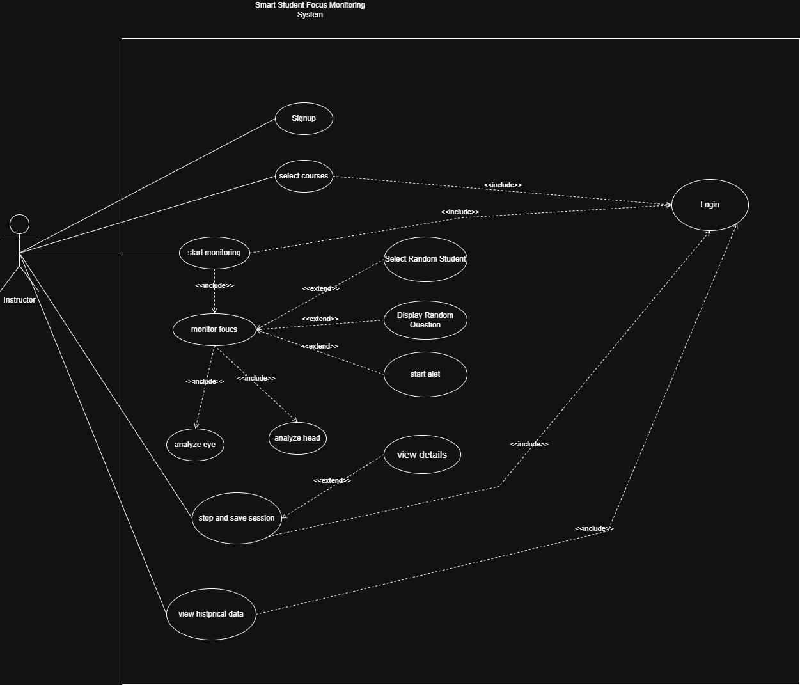
  - Use Case Specifications

  - Activity Diagrams for all complicated behaviors

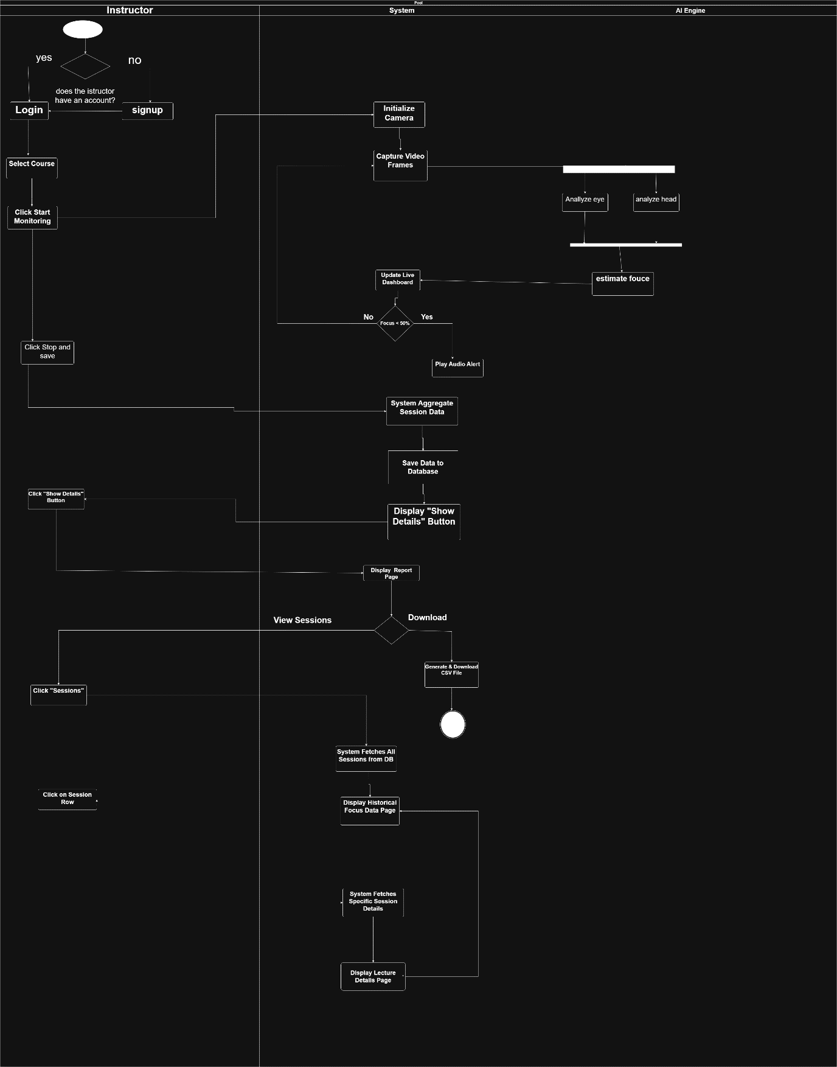

- Design Phase
  - Application Architecture Design (Context Diagram)

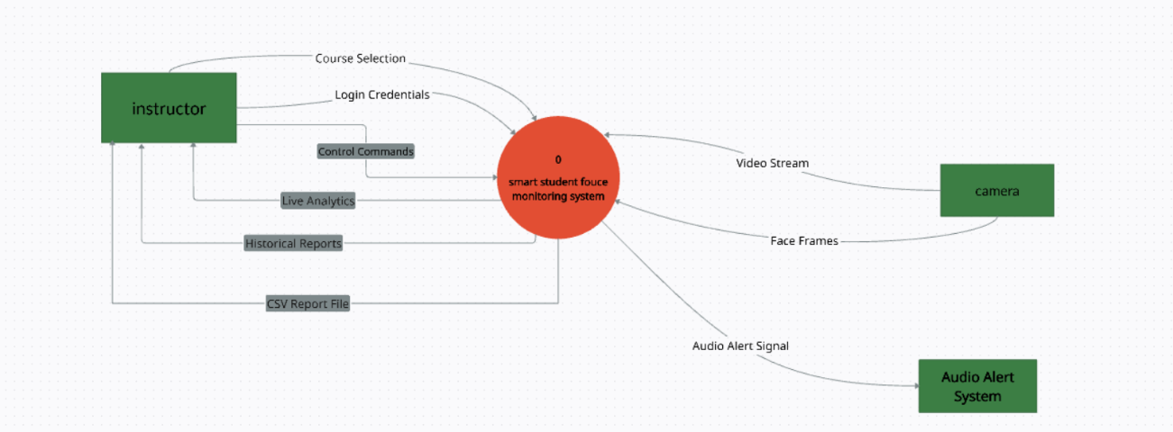

  - Data Architecture Design
